

Under the guidance of

Sagar Pande(Assistant Professor)

**PROJECT REPORT**

**A.I. Voice Assistant**



**PROJECT REPORT**

(Project Term AUGUST-DECEMBER,2019 )

**NOW**

(Notes On Web)

**Submitted By**

Name of student:Rishab charasiya Registration No:

Name of student:ShivShankar Mahato Registration No:11812651

Name of student:Mona Patel Registration No:

Under the guidance of

Name of faculty coordinator:Ms Payal Chhabra(Assistant Professior)

Name of faculty coordinator:Mrs.Sapna (Assistant Professior)

Course Code:CSE 77D

Course:-Python

Course Code:INT213

**Submitted By**

Name of student:Rishabh Chaurasiya

Registration No:12000736

Section:-K19JC

Roll No:-34

**Table of Content:**

* **Abstract**
* **Acknowledgement**
* **Introduction**
* **Objective**
* **System Description and Requirements**
* **Output Screenshots and Code**
* **Conclusion**

**Abstract**

In the Modern Era of fast moving technology we can do things which we never thought we could do before but, to achieve and accomplish these thought s there is a need for a plat form which can automate all our tasks with ease and comfort. Thus, we humans developed applications like Personal Voice Assistant having the ability to interact with the surroundings just by one of the materialistic forms of human interaction i.e. HUMANVOICE. The most famous application of android mobile phone is “Google Assistant”, “Google Voice Search” which is developed by the Google .Various applications like Microsoft Cortana, Amazon Alexa is also used as an voice assistant .The voice application of iphone is “SIRI” which helps the end user to communicate end-user mobile with voice and it also responds to the voice commands of the user. So, I developed a voice assistant in which we can give a command to perform small specific tasks locally which can save our time and can help us to be more interactive and productive. In this voice assistant we can access few websites by simply giving commands and we can play music randomly and many more.

**Acknowledgement**

Foremost, I would like to express my sincere gratitude to my advisor Mr. Sagar Pande for the continuous support in our studies and project. Their guidance helped us all the time to complete this semester project. I would also like to thank our parents, brothers and sisters for having given us their undisputable support throughout, as always, for which our expression of thanks likewise does not suffice. Also, we thank our friends and classmates for supporting us.

**Introduction**

The voice assistant is designed in a simple way where user only have to click on the “START” button and after that user can start giving command to perform the specific task, user can change the voice of assistant to other voice ,user can stop the assistant only by giving one single command and there are many tasks which assistant can perform by giving single command you can check it by interacting with the voice assistant.

**Objective**

The main objective of this A.I. based voice assistant is to make user more comfortable by performing small user-friendly tasks which feels more interesting to the users.

**System Description And Requirements**

To develop this voice assistant, I used IDLE as interpreter and the whole project is written in Python Programming Language.

To develop this voice assistant, I needed many libraries to import like: pyttsx3, speechrecognition, datetime, wikipedia, random, webbrowser, os and tkinter.

In this project there is a simple button named as “Start” when user will click on Start the assistant will get active and after that user can give command to perform task and if user wants to stop the assistant in between user can say “quite” the assistant will stop automatically.

**Output Screenshots And Code**

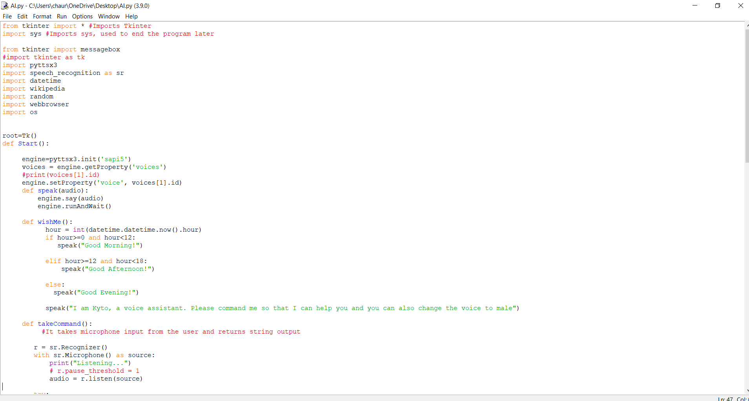

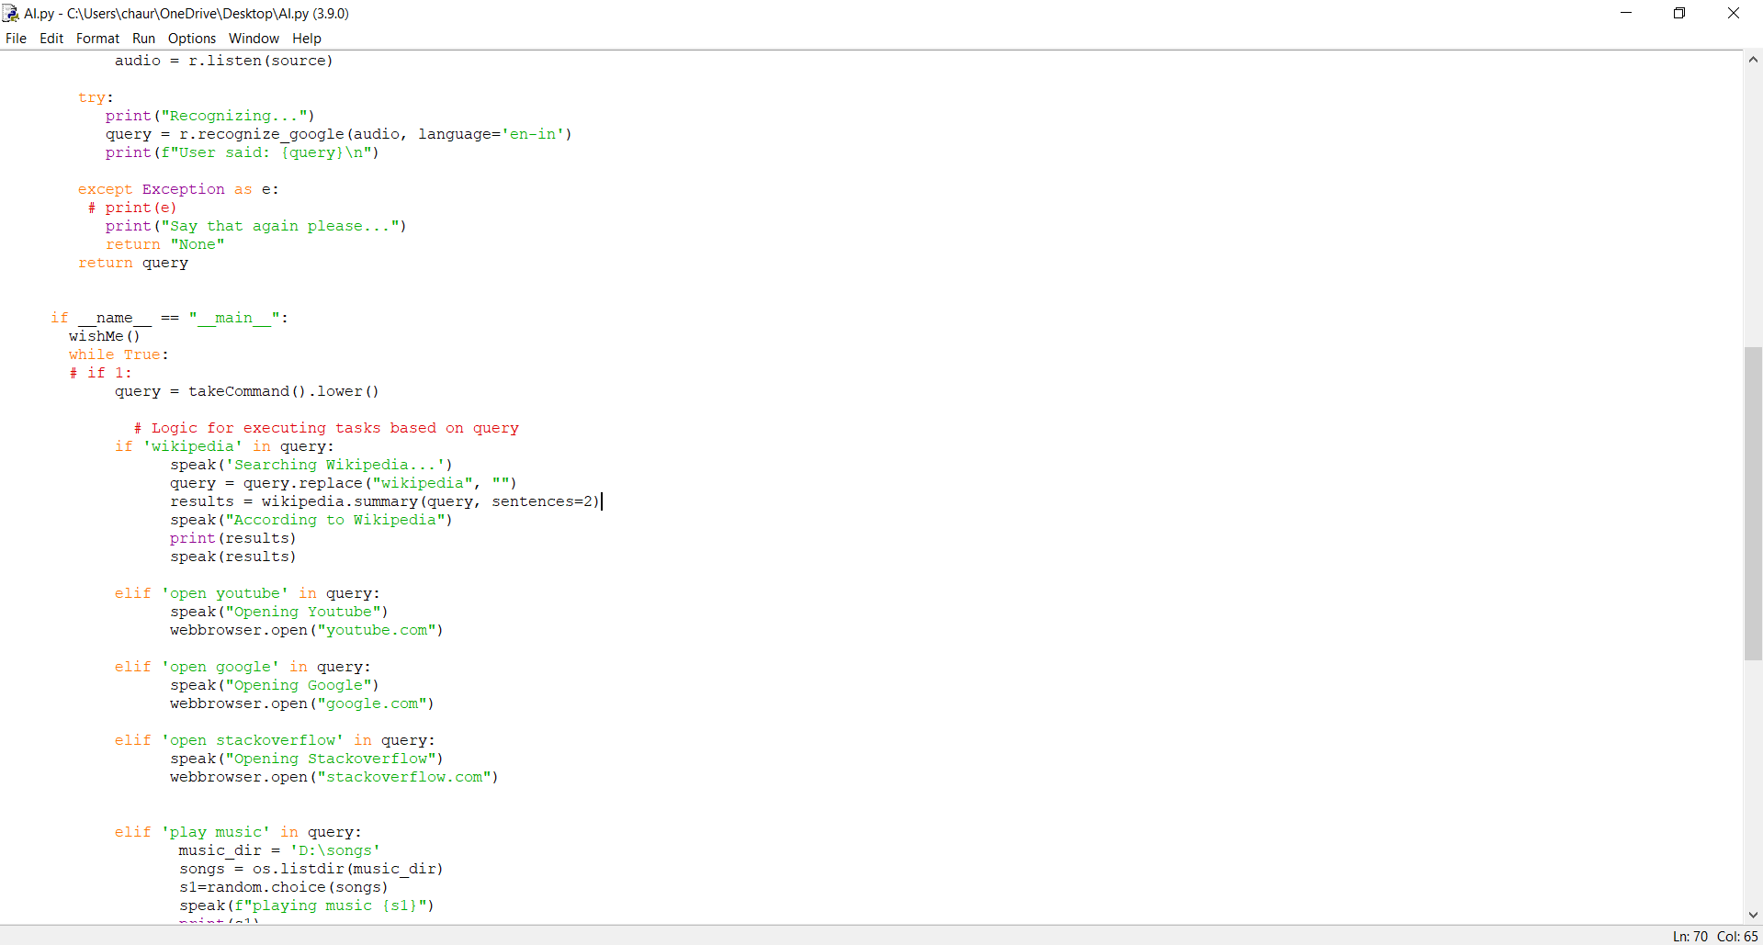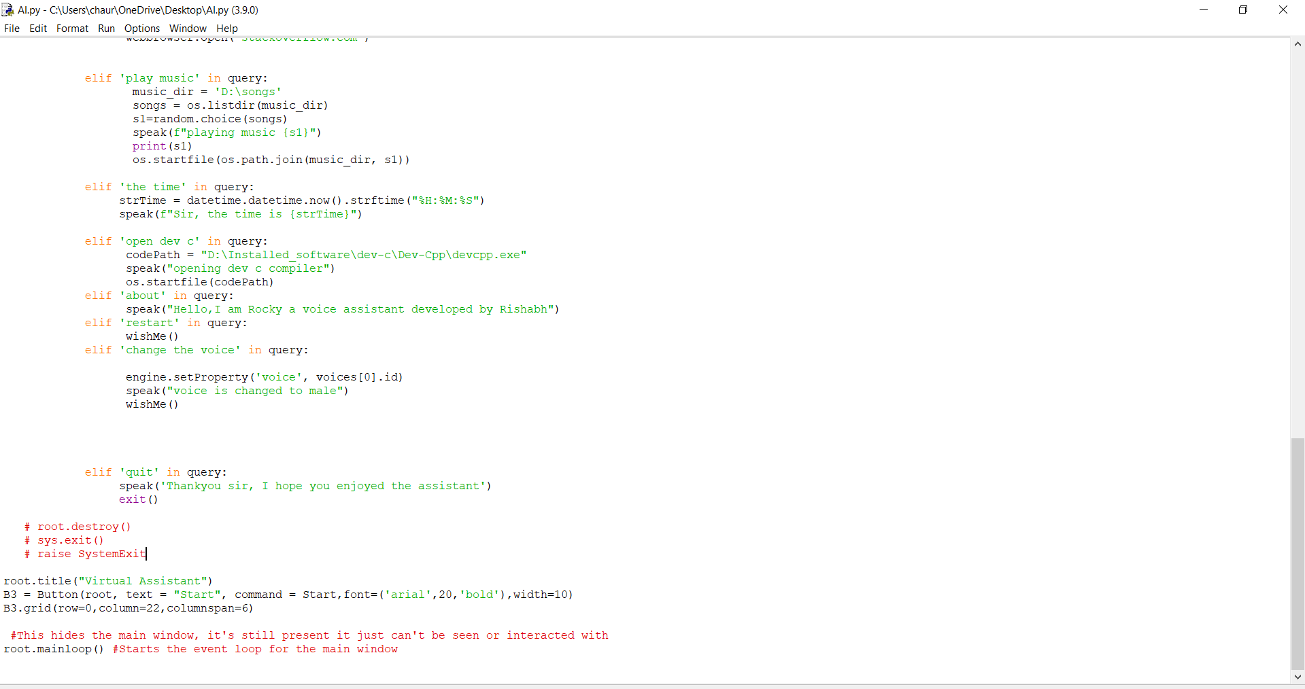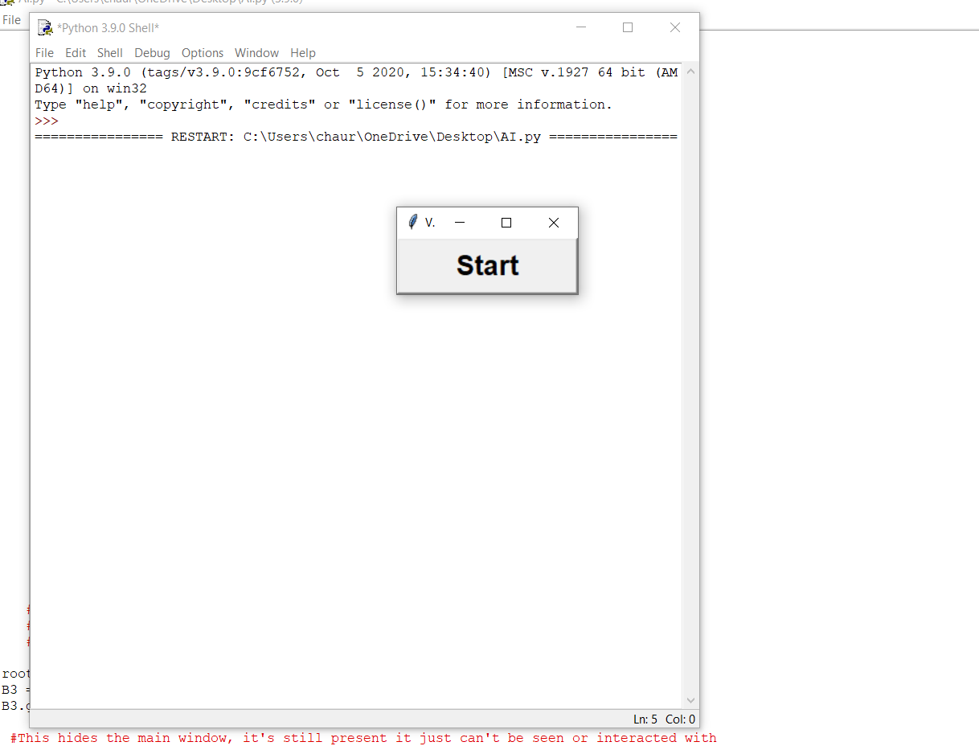

from tkinter import * #Imports Tkinter

import sys #Imports sys, used to end the program later

from tkinter import messagebox

#import tkinter as tk

import pyttsx3

import speech_recognition as sr

import datetime

import wikipedia

import random

import webbrowser

import os

root=Tk()

def Start():

engine=pyttsx3.init('sapi5')

voices = engine.getProperty('voices')

#print(voices[1].id)

engine.setProperty('voice', voices[1].id)

def speak(audio):

engine.say(audio)

engine.runAndWait()

def wishMe():

hour = int(datetime.datetime.now().hour)

if hour>=0 and hour<12:

speak("Good Morning!")

elif hour>=12 and hour<18:

speak("Good Afternoon!")

else:

speak("Good Evening!")

speak("I am Kyto, a voice assistant. Please command me so that I can help you and you can also change the voice to male")

def takeCommand():

#It takes microphone input from the user and returns string output

r = sr.Recognizer()

with sr.Microphone() as source:

print("Listening...")

# r.pause_threshold = 1

audio = r.listen(source)

try:

print("Recognizing...")

query = r.recognize_google(audio, language='en-in')

print(f"User said: {query}\n")

except Exception as e:

# print(e)

print("Say that again please...")

return "None"

return query

if __name__ == "__main__":

wishMe()

while True:

# if 1:

query = takeCommand().lower()

# Logic for executing tasks based on query

if 'wikipedia' in query:

speak ('Searching Wikipedia...')

query = query.replace("wikipedia", "")

results = wikipedia.summary(query, sentences=2)

speak("According to Wikipedia")

print(results)

speak(results)

elif 'open youtube' in query:

speak("Opening Youtube")

webbrowser.open("youtube.com")

elif 'open google' in query:

speak("Opening Google")

webbrowser.open("google.com")

elif 'open stackoverflow' in query:

speak("Opening Stackoverflow")

webbrowser.open("stackoverflow.com")

elif 'play music' in query:

music_dir = 'D:\songs'

songs = os.listdir(music_dir)

s1=random.choice(songs)

speak(f"playing music {s1}")

print(s1)

os.startfile(os.path.join(music_dir, s1))

elif 'the time' in query:

strTime = datetime.datetime.now().strftime("%H:%M:%S")

speak(f"Sir, the time is {strTime}")

elif 'open dev c' in query:

codePath = "D:\Installed_software\dev-c\Dev-Cpp\devcpp.exe"

speak("opening dev c compiler")

os.startfile(codePath)

elif 'about' in query:

speak("Hello,I am Rocky a voice assistant developed by Rishabh")

elif 'restart' in query:

wishMe()

elif 'change the voice' in query:

engine.setProperty('voice', voices[0].id)

speak("voice is changed to male")

wishMe()

elif 'quit' in query:

speak('Thankyou sir, I hope you enjoyed the assistant')

exit()

# root.destroy()

# sys.exit()

# raise SystemExit

root.title("Virtual Assistant")

B3 = Button(root, text = "Start", command = Start,font=('arial',20,'bold'),width=10)

B3.grid(row=0,column=22,columnspan=6)

#This hides the main window, it's still present it just can't be seen or interacted with

root.mainloop() #Starts the event loop for the main window

**Conclusion**

Smart speakers use has spread with impressive speed. The voice assistant technology is more than affordable and offers many benefits to its users. Having a personal assistant with access to the unlimited knowledge stored on the internet - isn’t this what mankind dreams about?